**DAILY ONLINE ACTIVITIES SUMMARY**

|  |  |  |  |  |  |  |  |  |
| --- | --- | --- | --- | --- | --- | --- | --- | --- |
| Date: | 29/05/2000 | | | | | Name: | Jyothi B R | |
| Sem & Sec | IV-A | | | | | USN: | 4AL18CS030 | |
| Online Test Summary | | | | | | | | |
| Subject | | Operating System | | | | | | |
| Max. Marks | | 25 | | Score | | | 30 | |
| Certification Course Summary | | | | | | | | |
| Course | Programming Essentials in Python | | | | | | | |
| Certificate Provider | | | Cisco Virtual Academy | | Duration | | | 2.5hrs |
| Coding Challenges | | | | | | | | |
| Problem Statement. 1Amstrong using c.  2. Binary matrix using java. | | | | | | | | |
| Status:Completed | | | | | | | | |
| Uploaded the report in Github | | | | | Yes | | | |
| If yes Repository name | | | | | https://github.com/alvas-education-foundation/jyothi_b_r | | | |
| Uploaded the report in slack | | | | | Yes | | | |

Online Test Details: (Attach the snapshot and briefly write the report for the same)

Certification Course Details: (Attach the snapshot and briefly write the report for the same)

Coding Challenges Details: (Attach the snapshot and briefly write the report for the same)

ONLINE TEST DETAILS:

The online test was from module 2. There were 30 questions which contains 30 mcq questions and the duration were 30 minutes. The questions were optimal and easy. The score that I received was 25/30.

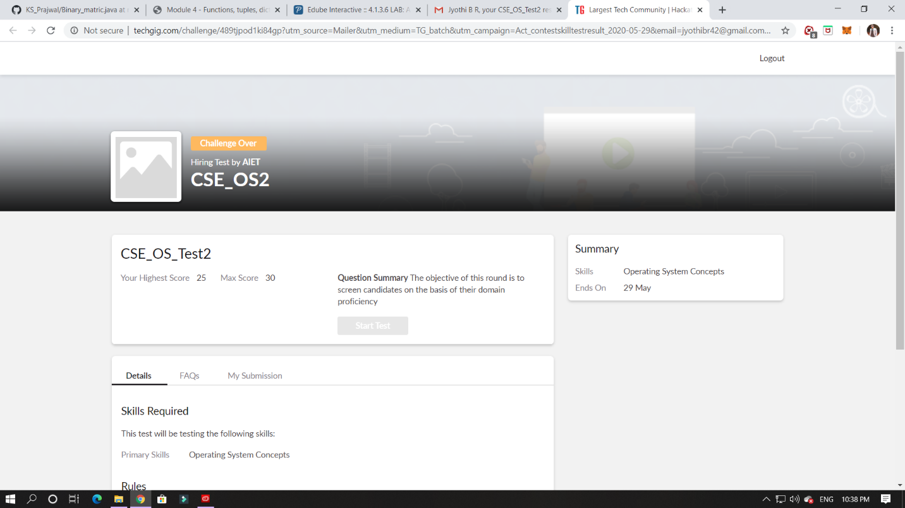

CERTIFICATION COURSE DETAILS:

Programming Essentials in Python :

**Parametrized functions**

The function's full power reveals itself when it can be equipped with an interface that is able to accept data provided by the invoker. Such data can modify the function's behavior, making it more flexible and adaptable to changing conditions.

In this class it says about how to define the function and parameters. Which is used to initialise the value inside and outside the parantheses.

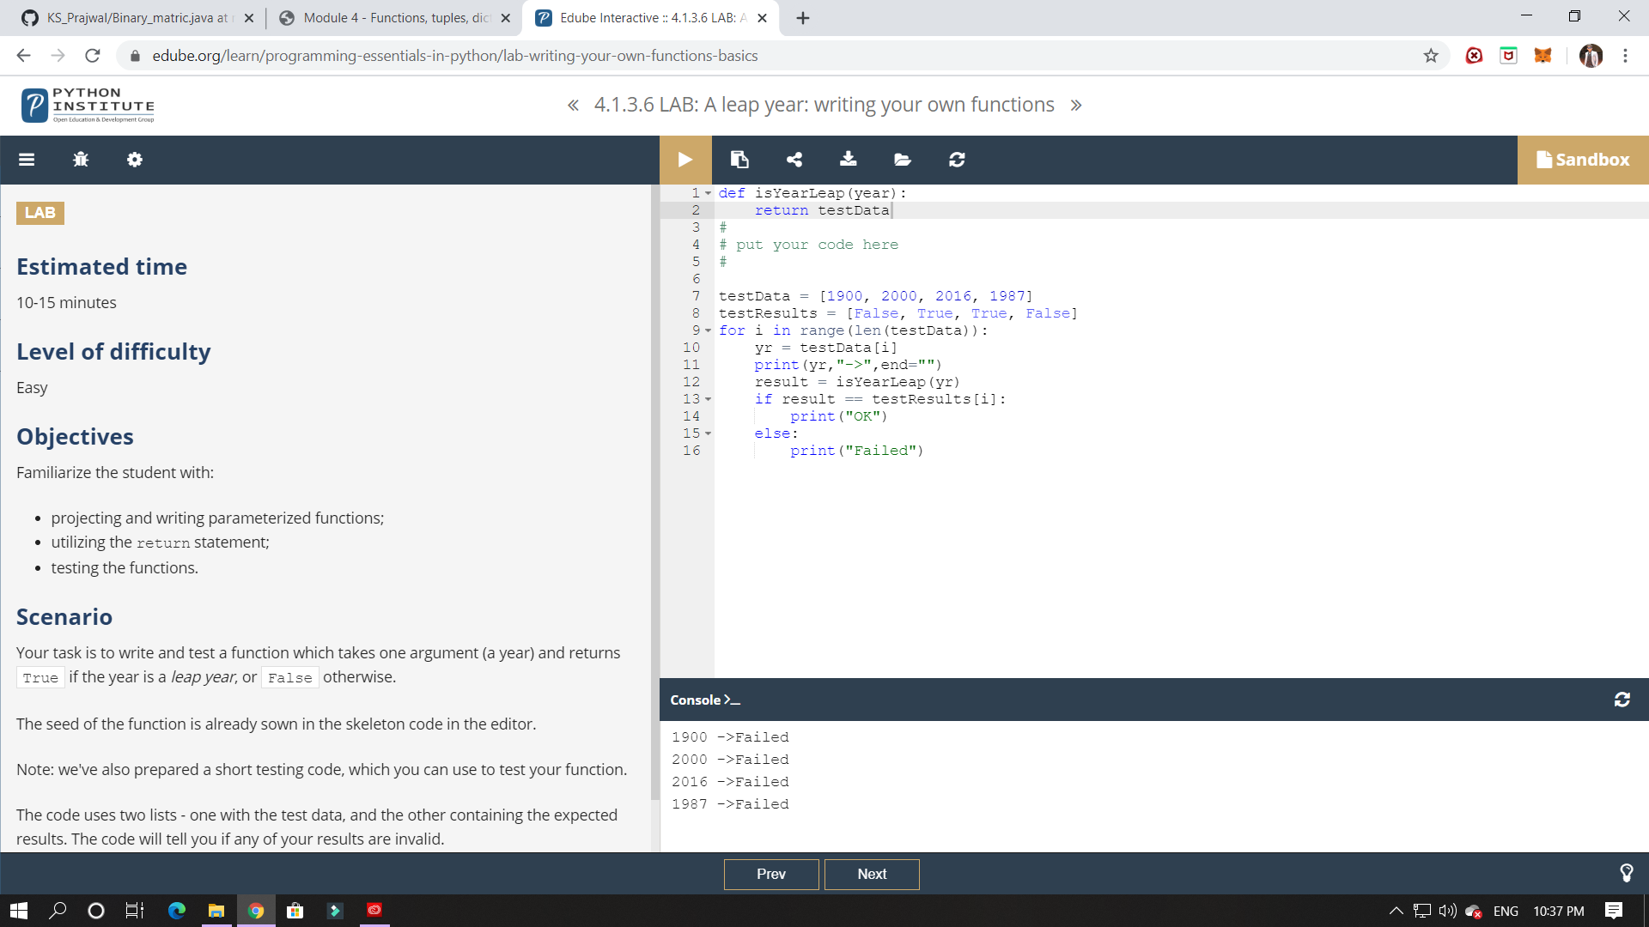

ONLINE CODING:

1.Armstrong number is a number that is equal to the sum of cubes of its digits. For example 0, 1, 153, 370, 371 and 407 are the Armstrong numbers.

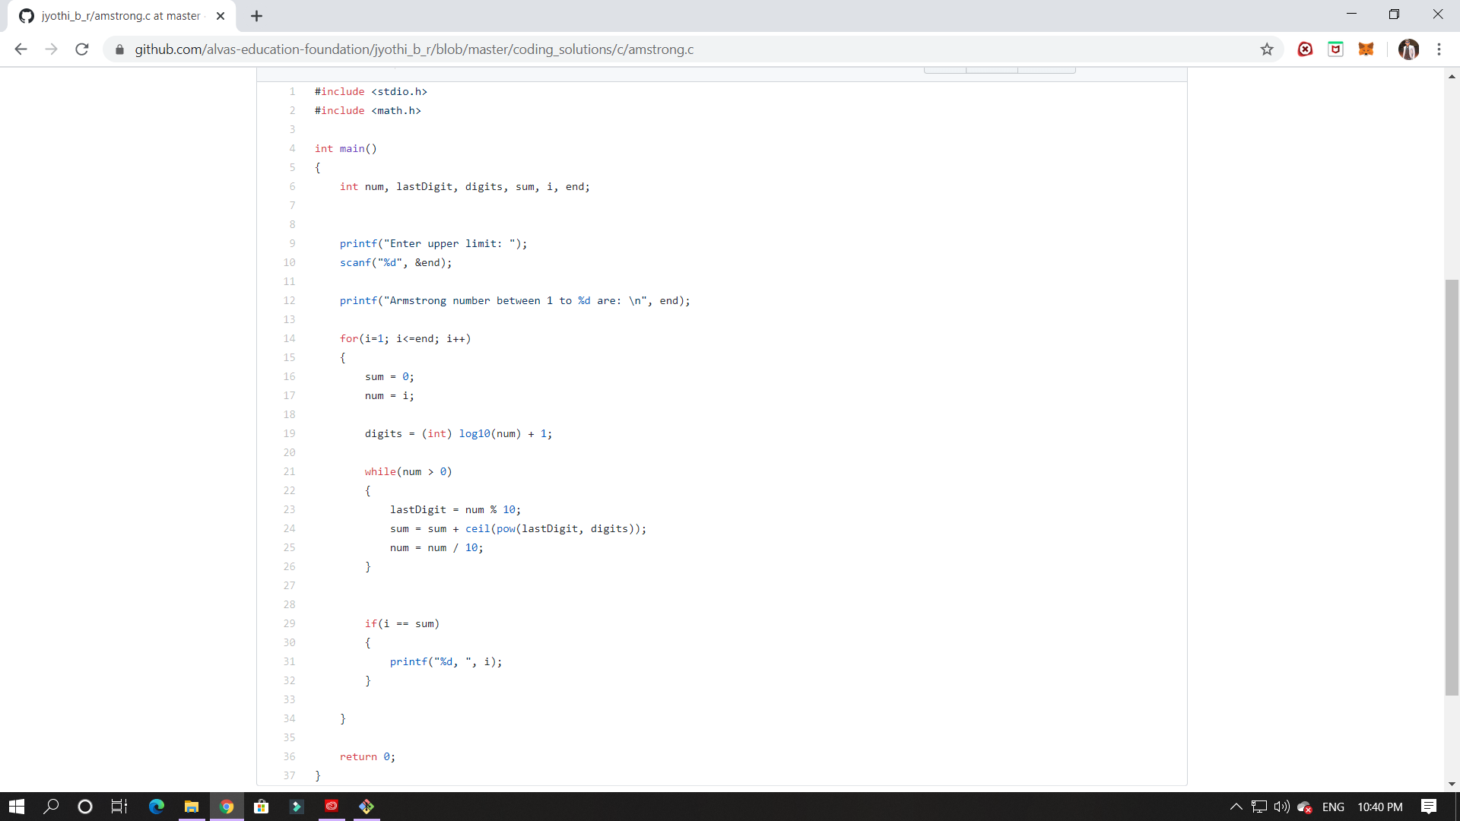

2. Given a N X N binary matrix, find the size of the largest ‘+’ formed by all 1s.

For above matrix, largest ‘+’ would be formed by highlighted part of size 8.

The idea is to maintain four auxiliary matrices left[][], right[][], top[][], bottom[][] to store consecutive 1’s in every direction. For each cell (i, j) in the input matrix, we store below information in these four matrices –

left(i, j) stores maximum number of  
consecutive 1's to the left of cell (i, j)  
including cell (i, j).

right(i, j) stores maximum number of  
consecutive 1's to the right of cell (i, j)  
including cell (i, j).

top(i, j) stores maximum number of  
consecutive 1's at top of cell (i, j)  
including cell (i, j).

bottom(i, j) stores maximum number of  
consecutive 1's at bottom of cell (i, j)  
including cell (i, j).

After computing value for each cell of above matrices, the largest + would be formed by a cell of input matrix that has maximum value by considering minimum of (left(i, j), right(i, j), top(i, j), bottom(i, j) )

